**Assignment Day - 1**

**1. Installed Kali Linux in VMware Player.**

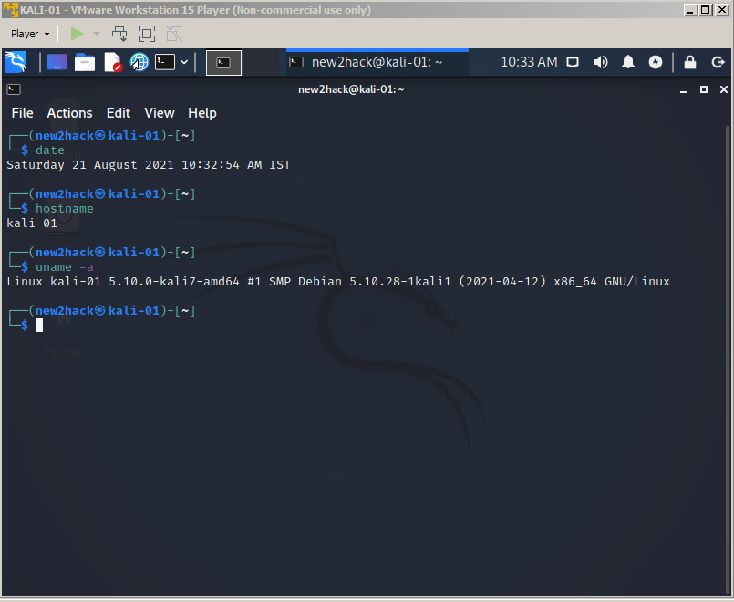

**2. Different Linux Commands**

**1. uname** - uname (**short for Unix name**) prints the name, version and other details about the current machine and the operating system running on it.

Syntax: **uname [OPTION]**

Below are the options.

**uname -a** : It prints all the system .



**uname -s**: It prints the kernel name.



**uname -n**: Prints the network node hostname



**uname -r**: Prints the kernel release



**uname -v**: Prints the kernel version



**uname -m**: Prints the machine hardware name



**uname -p**: Prints the processor type (non-portable)



**uname -i**: Prints the hardware platform (non-portable)



**uname -o**: Prints the operating system



**uname --version**: Displays the version information and exit

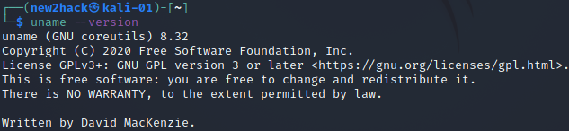

**uname --help**: Display this help and exit

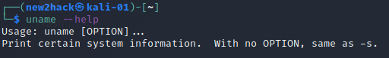

**touch:** Touch creates an empty file

**Syntax:** touch <FileName>



**echo:** Displays a line of text to standard output

We can also redirect the output to other files using > (Overrides) and >> (Appends).





**cat:** Displays the content of a file

**Syntax:** cp <File>



**cp:** Copies the files from one location to another location in the serer keeping the original file in the source.

**Syntax:** cp <source> <destination>



**mv:** Moves a file from source to destination with no copy in the source location

**Syntax:** mv <source> <destination>



mkdir: Creates a Directory

**Syntax:** mkdir <DirectoryName>



**cd:** Change the Directory

**Syntax:** cd <DirectoryPath>



**pwd:** Prints the working Directory



**ls:** Lists the directory contents

**Syntax:** ls [options] [File/Directory]

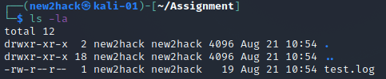

**rm:** Removes a file or a directory

**Syntax:**

To remove a file forcibly, use "**rm -f <FileName>**"



To remove a directory recursively, use "**rm -f <FileName>**"



**ifconfig:** To display and configure Interface information

